# **Design Document**

1. **Data Flow Diagram:**

This image is a Data Flow Diagram (DFD) representing the flow of information between different processes, data stores, and external entities. Here is a brief description of the diagram's components:

**1. External Entities:**

- *System Admin:* Provides product information.

- *Customer:* Provides information, manages subscriptions, and places orders.

**2. Processes:**

- *Product Management:* Receives product info from the System Admin and stores it in Product Data.

- *Customer Management:* Handles customer information and stores it in Customer Data.

- *Subscription Management:* Manages customer subscriptions and updates customer data.

- *Order Processing:* Processes orders placed by customers and updates Order Data.

- *Order Item Processing:* Handles individual order items and stores this data in Order Item Data.

*- Delivery Scheduling:* Schedules deliveries and stores the schedule data in Delivery Schedule Data.

- *Order History Recording:* Records order history by consolidating information from various data stores.

**3. Data Stores:**

- *Product Data:* Stores information about products.

- *Customer Data:* Stores customer-related information.

- *Order Data:* Stores data related to orders placed.

- *Order Item Data:* Stores data for individual items within orders.

- *Delivery Schedule Data:* Stores delivery scheduling information.

- Subscription Data: Stores subscription-related information.

- *Order History Data:* Stores historical data about processed orders.

**4. Data Flow:**

- Arrows represent the flow of information between external entities, processes, and data stores.

**5. Interactions:**

- Customers interact with Customer Management and Subscription Management.

- System Admin interacts with Product Management.

- Data from multiple processes is funneled into Order History Recording to maintain a comprehensive record of transactions.

1. **Class Diagram:**

1. **Use Case Diagram:**

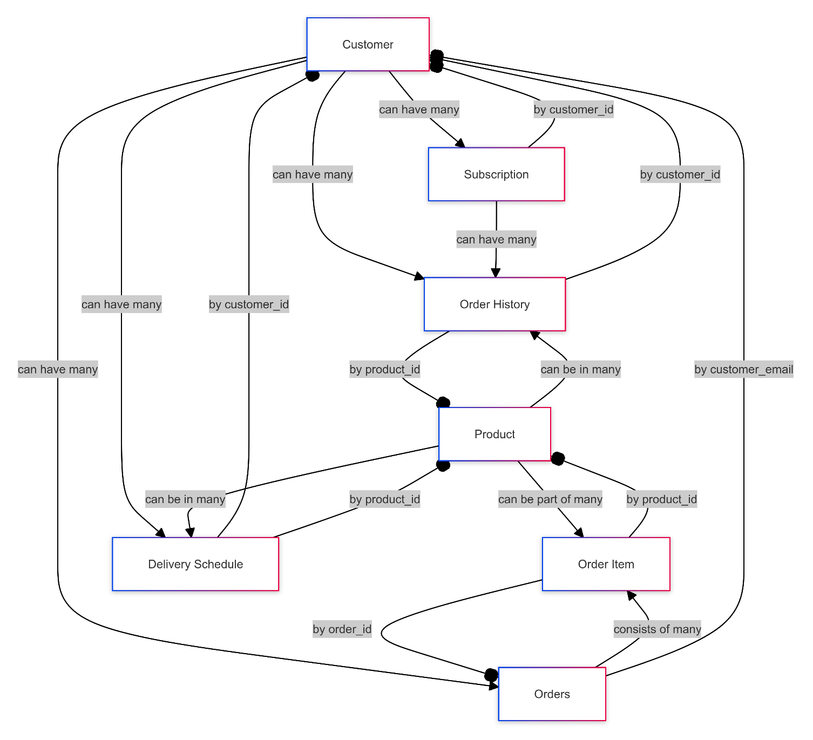

1. **Entity Relationship (ER) Diagram:**

